Constitutional Awareness

**She Team**

ACP Puja was in our campus giving suggestions regarding the various protective measures students should take. She is a very versatile speaker who was giving suggestions as to how to beware about strangers and take care of themselves. An extremely experienced speaker she was quoting from her experience and gave a number of case studies as an example to drive home her point. She emphasized the parents to ensure that they knew to whom their children were talking or chatting. She also asked the students to restrain the use of whattsapp, facebook and be careful while using them. She also promised the students that any complaint filed by the students would be registered immediately.

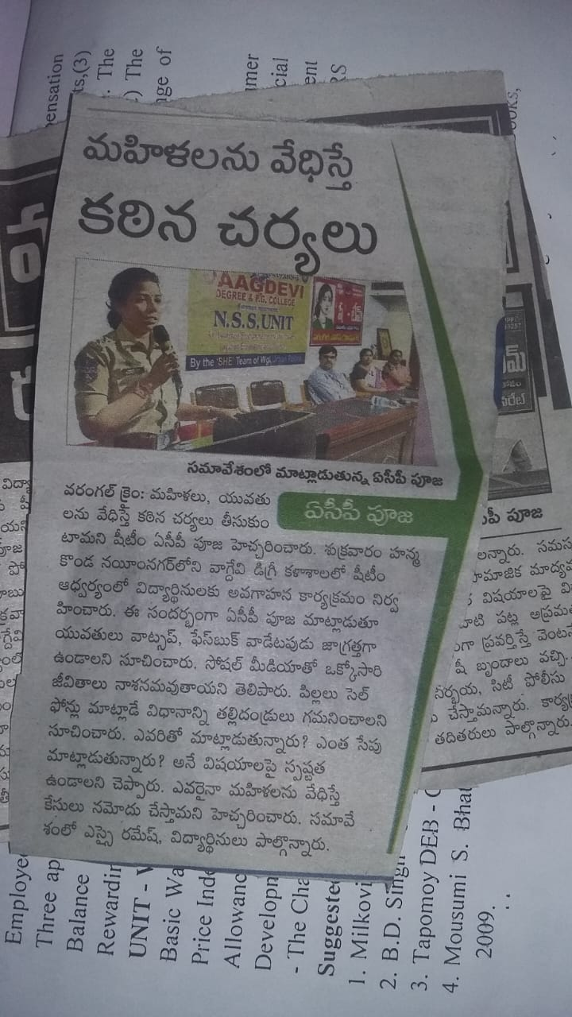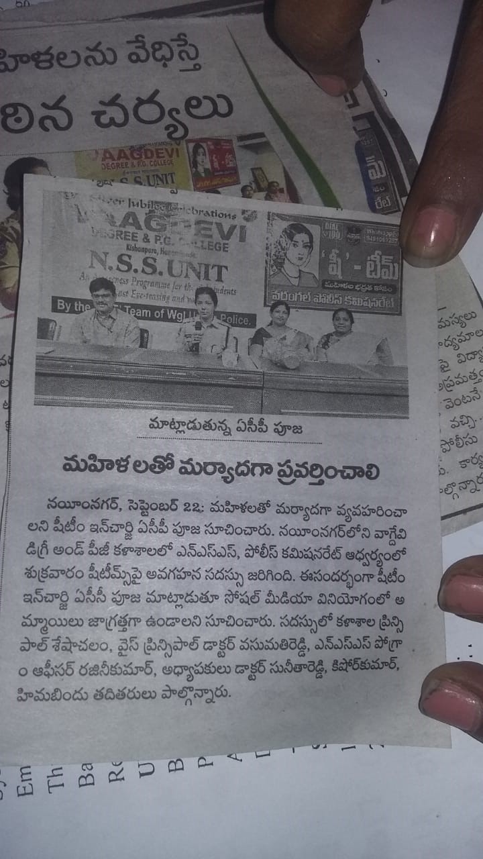

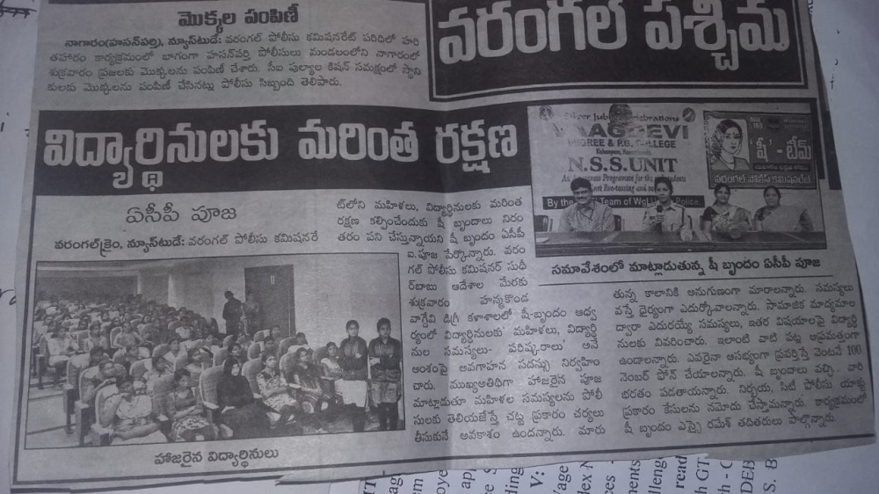

**Legal awareness:**

Prof. Padma presented a lecture on Legal Awareness for the benefit of students and faculty. Women have to know their rights. She spoke extensively on Domestic violence. and Dowry Prohibition and the laws related to them. To emphasize on this point, a quiz competition too was conducted to assess the students. Moreover Elocution competition was conducted on Dowry prohibition and Debate competition was conducted on Domestic violence. An extremely experienced Lawyer in teaching profession, her talk was extremely inspirational and motivating to the students. Dowry Prohibition act 1986, an act to prohibit the giving or taking of dowry that is any property or valuable security given or agreed to be given either directly or indirectly by any party of parents of either side at the time of marriage, or before or after the marriage ceremony.

Domestic Violence Act

Domestic Violence Act 2005 is the protection of women from domestic violence. It includes Physical violence, other forms of violence such as emotional and psychological abuse. Women form the largest group of victims of domestic violence, since time immemorial and violence against women still continue even in the 21st century. Domestic violence is not just limited to women, men , children and elderly people can also be victims of it.

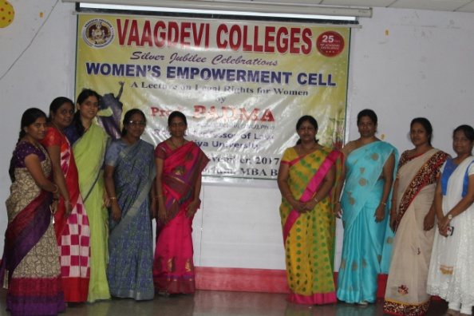

**Debate on Domestic Violence 2017**

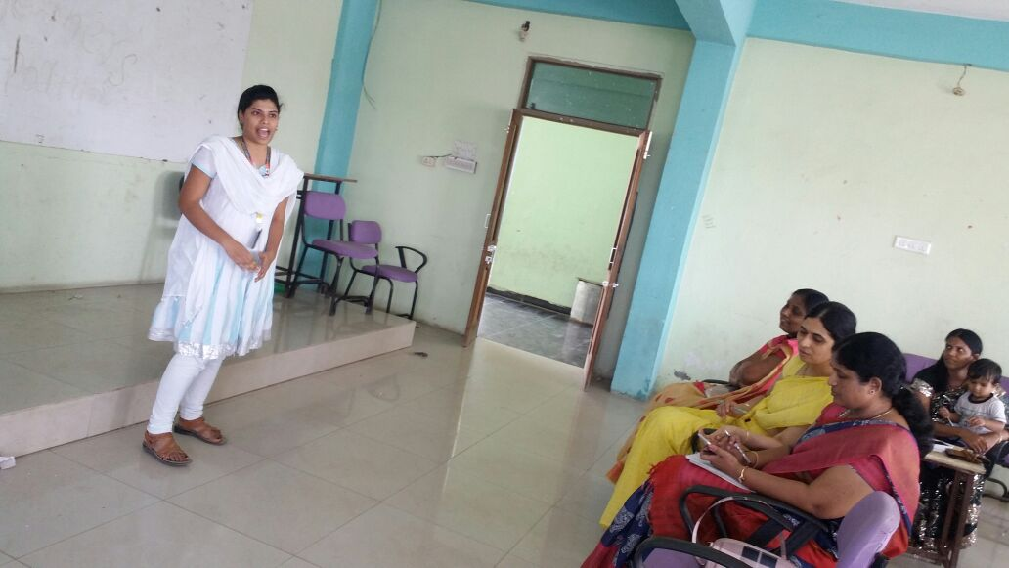

Elocution On Dowry Prohibition act 2017

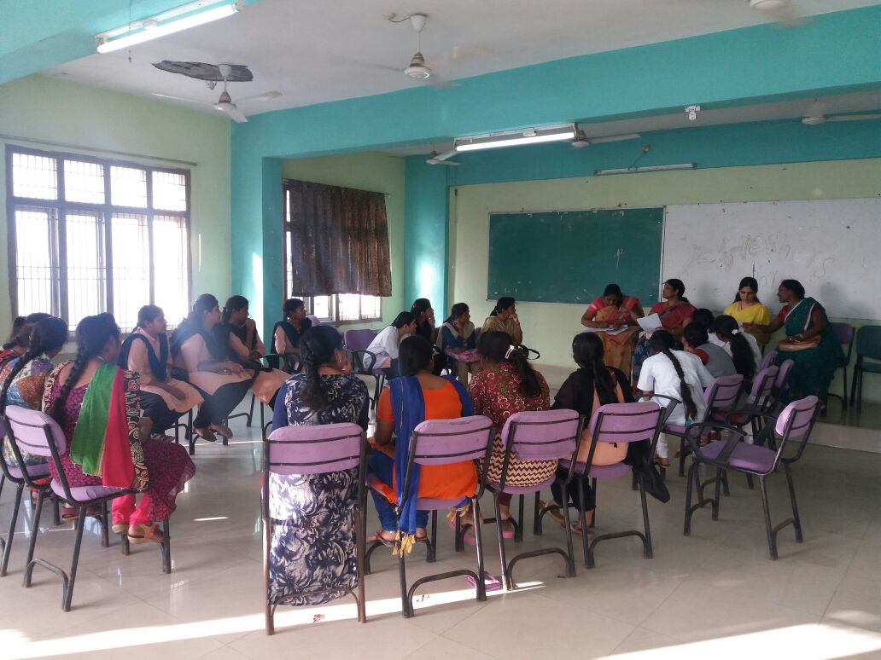

**Legal Rights Awareness:**

Prof. B. Vijayalakshmi addressed the girl students on Legal rights. She very clearly highlighted about the importance of Duties too. Her talk was very well received by the students. She patiently explained to the students their general behavior and how they tend to err. She emphasized on the fact that our attitudes too should change and we should not talk only about our rights.

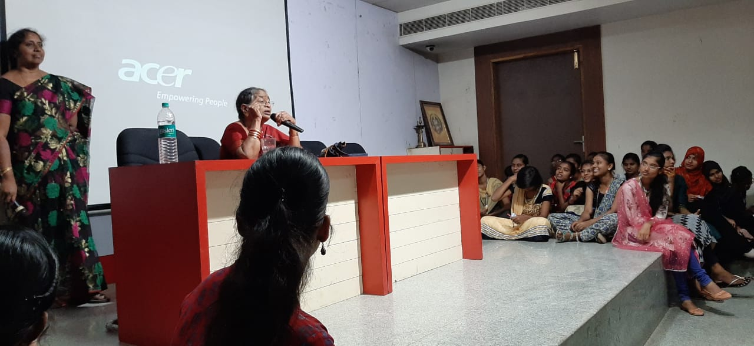

Prof B.VijayaLakshmi Former Principal of Law college addressing the girl students on ‘Rights of women as well as Duties’ on 1.2.2020.

**Right to Education**

**The constitution Act 2002 inserted article 21-A in the constitution of India to provide free and compulsory education of all children in the age group of 6-14 years as a fundamental right. The act provides for the right of free and compulsory education to children until they complete their elementary education in a school in the neighbourhood. It promotes Individaul freedom and empowerment and yields important development benefits.**

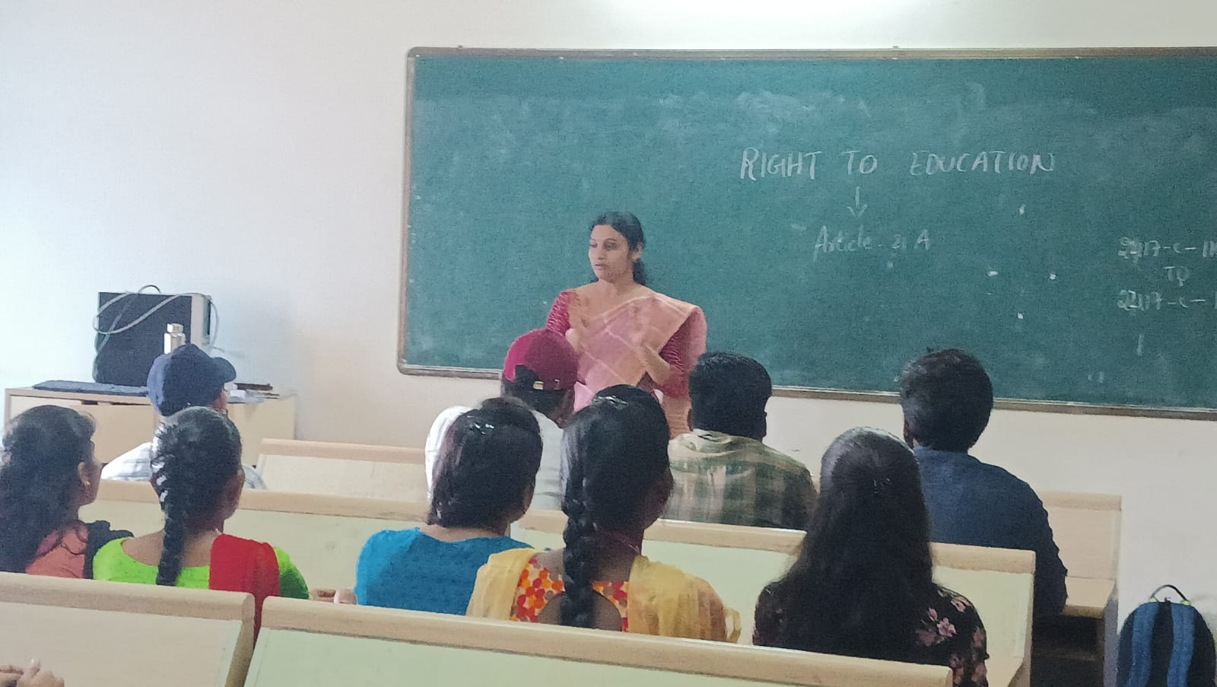

**Talk delivered by Smt.T.Anusha on Right to Education**

**Freedom Of Expression**

**Freedom of expression is a principle that supports the freedom of an individual or a community to articulate their opinions and ideas without fear of retaliation, censorship or legal sanction. It includes the freedom to seek, receive and impart information and ideas of all kinds, regardless of borders, whether orally, in writing or in print, by way of art or in another way**

**chosen by him or her.**

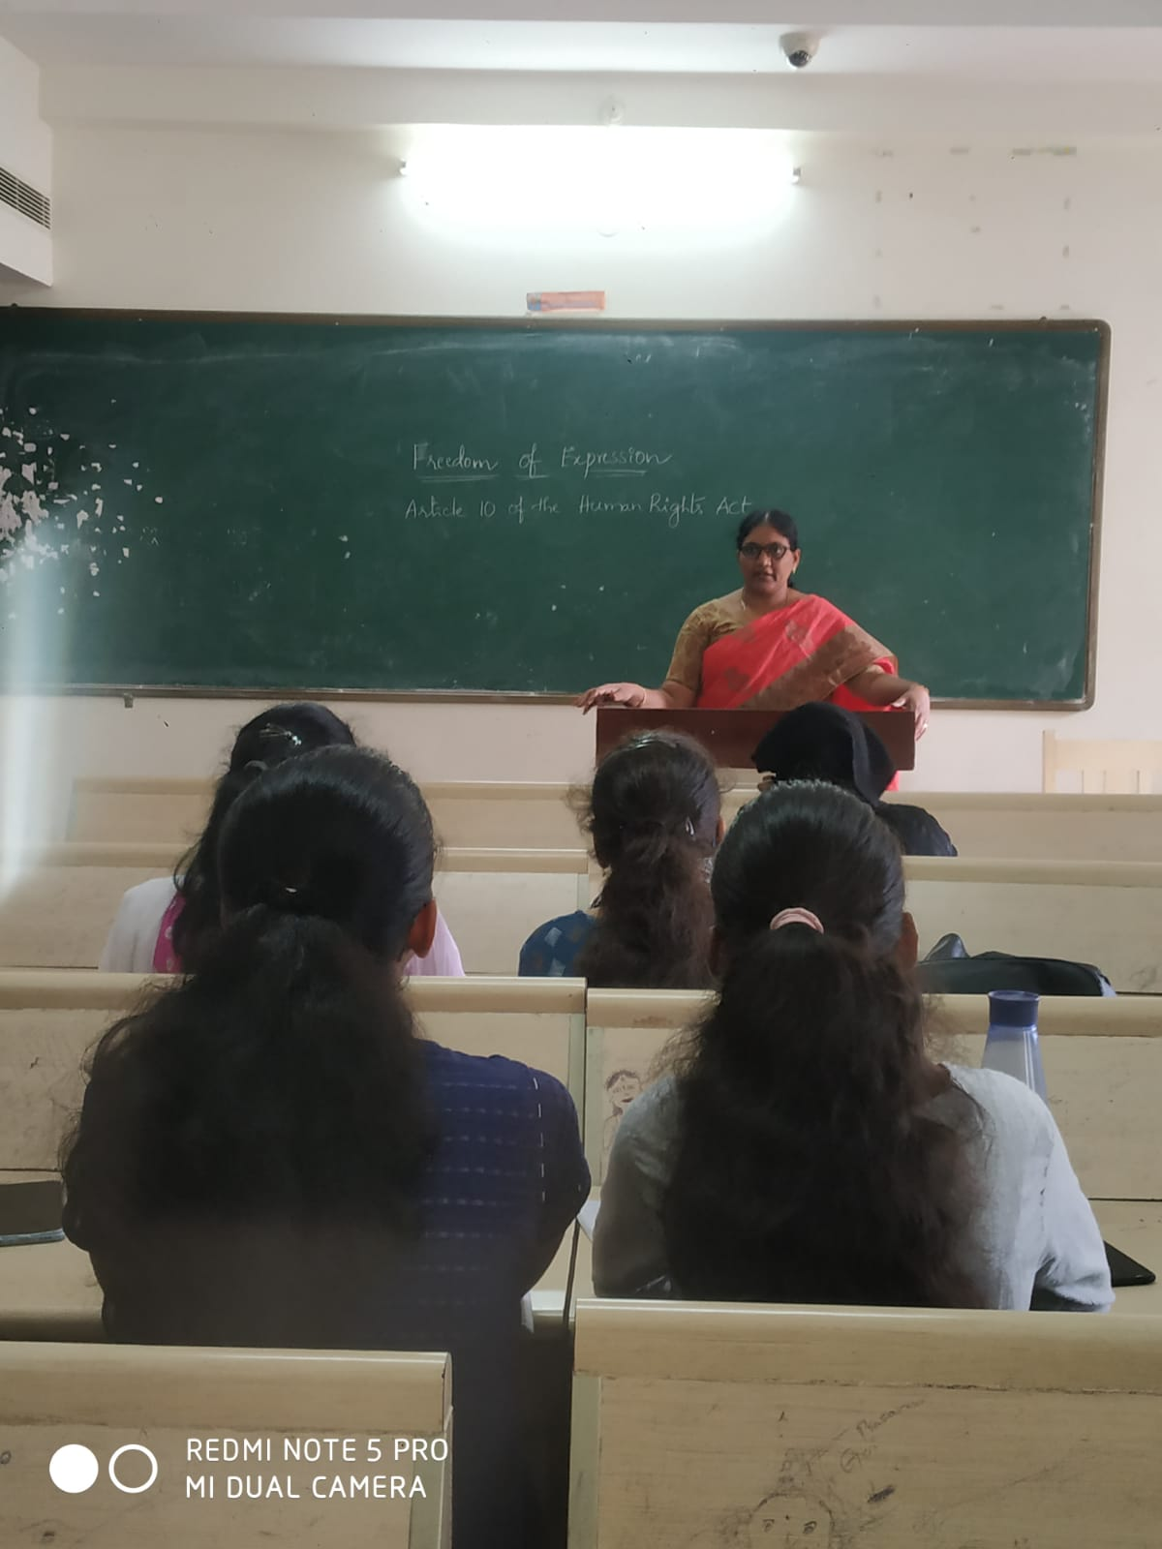

Freedom of expression talk delivered by Smt.Ch.Karuna

**Right to Equality**

**The constitution of India has granted the right to equality to all citizens. All are equal before the law and there can be no discrimination on the basis of religion, race, caste, gender, place of birth. The right to Equality provides for the equal treatment of everyone before the law, prevents discrimination on various grounds, treats everybody as equals in matters of public employment and abolishes untouchability, and titles.**

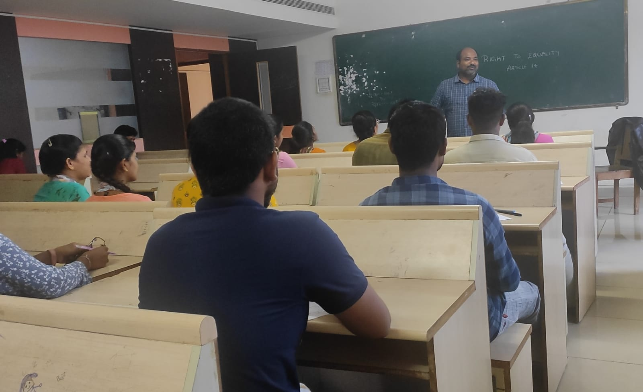

**Awareness created by Sri.Kishore on Right to equality**

**Anti Ragging Act**

**In 2009 the University Grants commission of india imposed regulations upon Indian Universities to help curb ragging and launched a Toll free antiragging helpline. Ragging is a subset of bullying unlike various complex forms of bullying ragging is easily recognizable. Ragging is a term used for the so called initiation ritual practiced in higher education Institutions in the Indian subcontinent. Ragging involves abuse humiliation or harassment of new entrants. It often takes a malignant form, wherein the new comers may be subjected to physiological or physical torture. Our college is strictly preventing ragging and we can boast that our campus is ragging free. Prohibition and eradication of ragging act 2019 was promulgated.**

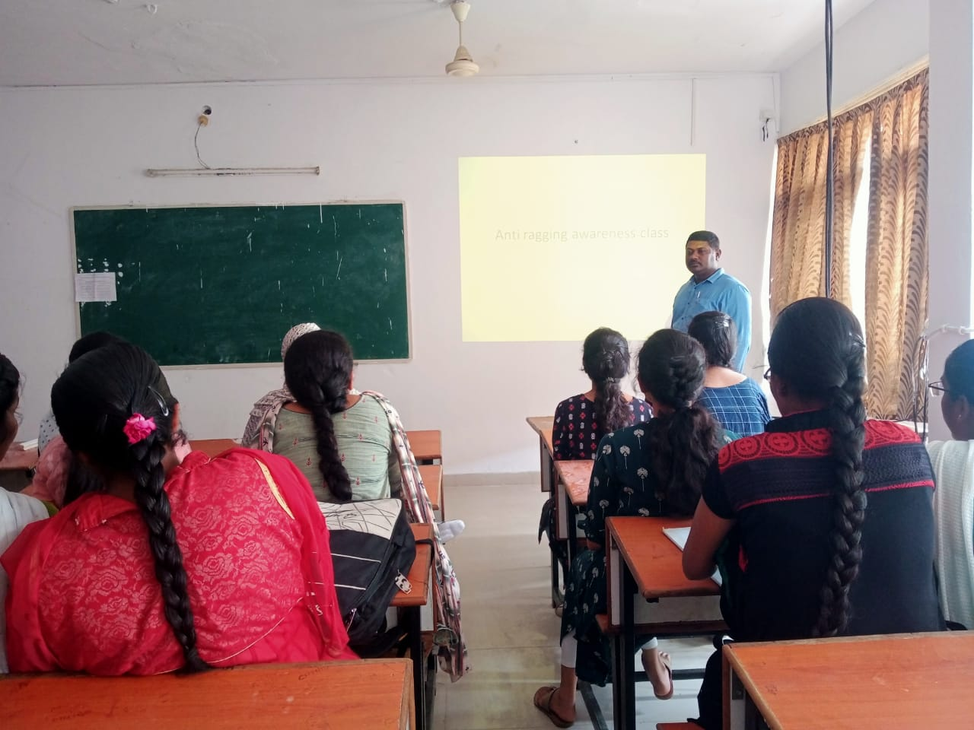

**Awareness created by Dr.P.Suresh regarding Anti-Ragging and the punishments involved**

**Female feticide:**

**Female feticide in India is the abortion of a female fetus outside of legal methods. A natural sex ratio is assumed to be between 103 and 107 males per 100 females at any number above it is considered suggestive of female feticide. The child sex ratio is between the normal natural range in all eastern and southern states of India. Significantly higher in certain western and particularly north-western states. Female feticide is a gender selective abortion where a female fetus is illegally terminated solely based on the reason that the fetus is a girl.** 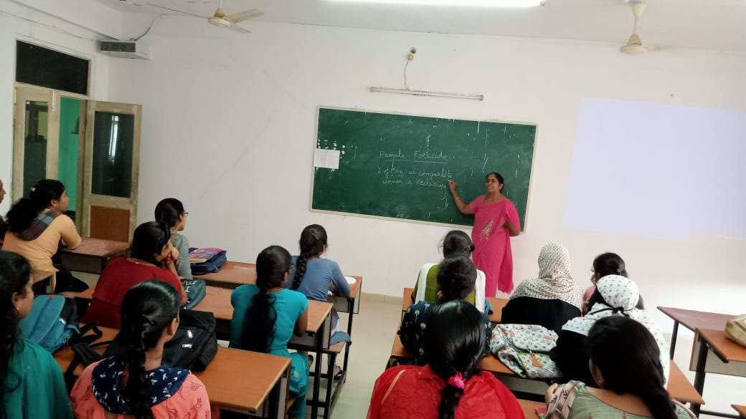

**Female feticide lecture delivered by Dr.C.Padmavati**

**Prevention of corruption act:**

**Prevention of Corruption Act is a stock short title used for legislation in India relating to corruption and bribery. The bill for an act with this short title will have been as a prevention of Corruption bill during its passage through parliament. Prevention of Corruption Act may be a generic name either for legislation bearing that short title or for all legislation which relates to corruption. It is a term of art in the united Kingdom.**

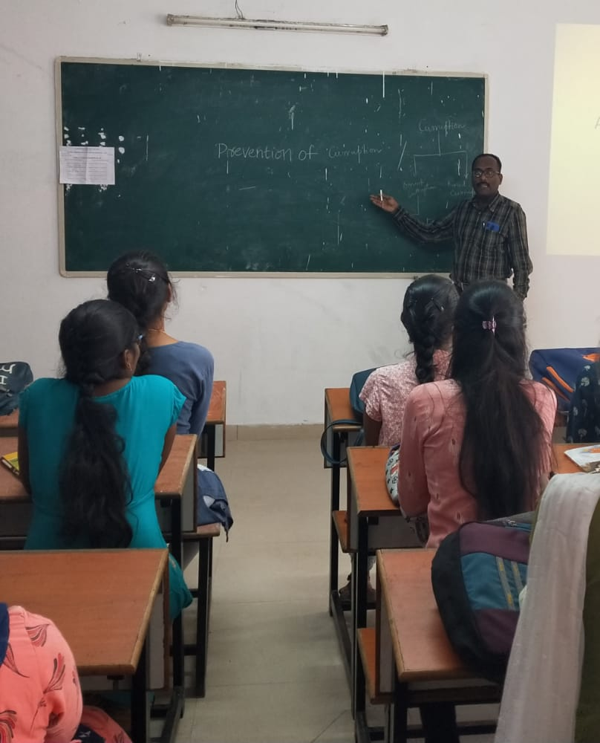

**Awareness regarding prevention of corruption by Dr.G.Raja prasad**

**Prevention of environmental pollution**

**Pollution prevention is any practice that reduces, eliminates or prevents Pollution at its source, before it is created. As shown by the EPA waste management hierarchy, pollution prevention is fundamentally different and feasible, more desirable than recycling, treatment or disposal. It is 0ftern more cost effective to prevent pollution from being created at source than to pay for control, treatment and disposal of waste product. Then less pollution is created, they are fewer impacts to human health and environment.**

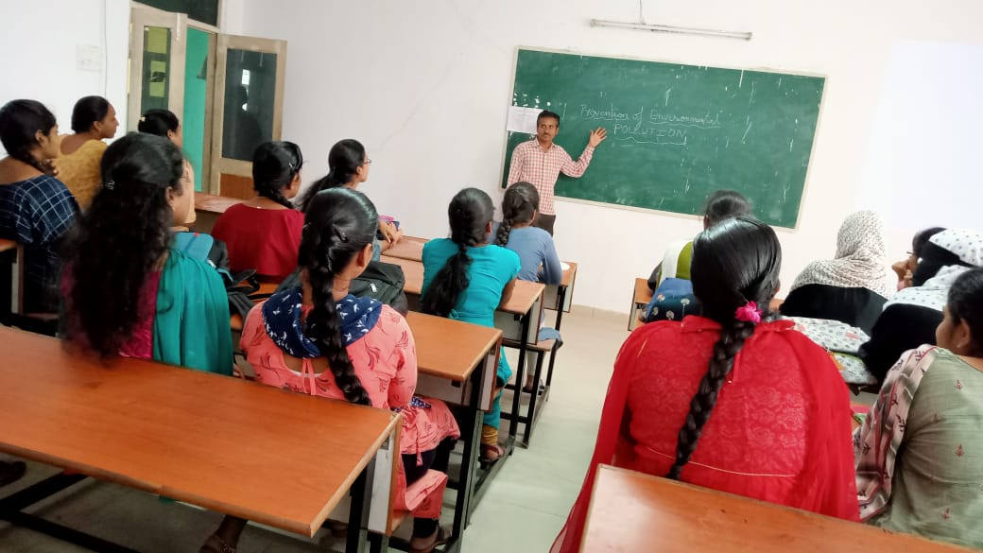

**Awareness created regarding prevention of pollution by Sri.G.Madhukar**

**Nirbhaya Act 2013**

**2012 Delhi gang rape and murder case involved a rape and fatal assault that occurred on 15 december 2012 in Munirka neighbourhood south-west Delhi. The incident took place when Jyothi Singh a 22 years old physiotherapy intern was beaten gang-raped and tortured in a private bus in which she was travelling with her male friend. There were 6 others in the bus including the driver, all of whom raped the woman and beat her friend. This was implemented in 2013. Under its purview acid attack, sexual harassment stalking trafficking of person are included.**

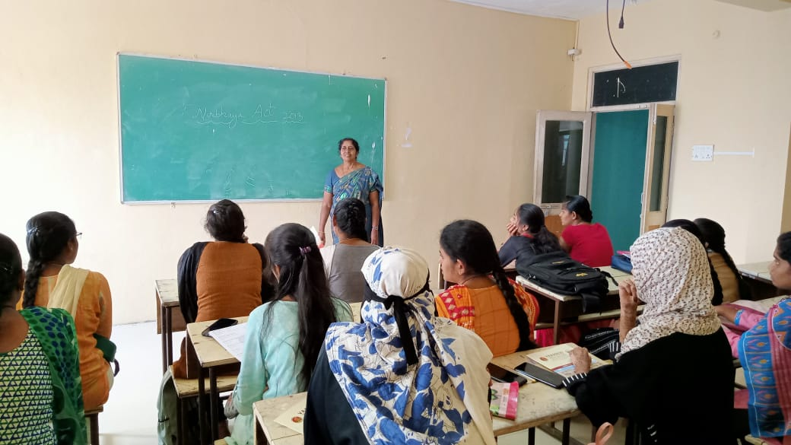

**Awareness created on Nirbhaya act by Dr.C.Padmavati**

**Anti Sexual Harassment Act 2013:**

**An act to provide protection against sexual harassment of women at workplace and for the prevention and redressal of complaints of sexual harassment and for matters connected therewith or incidental thereto.**

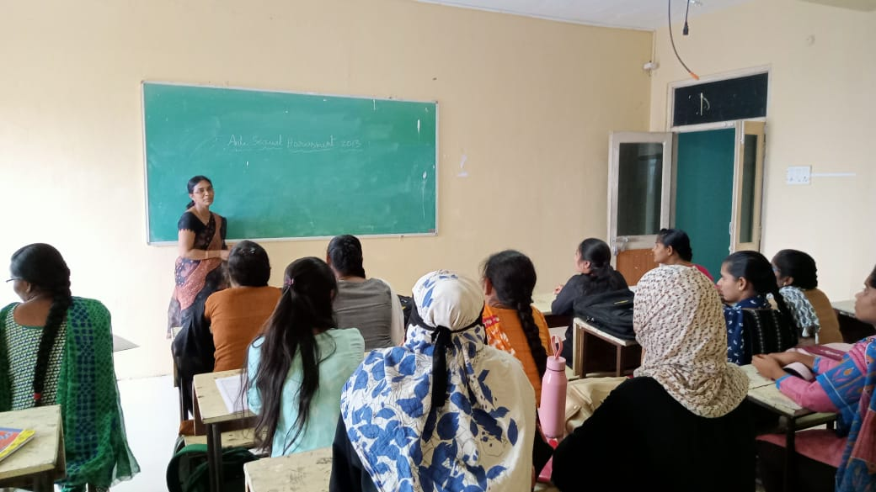

**Awareness created by Smt.S.Rajitha regarding Anti Sexual Harassment act**

**Beti Bachao Beti Padhao**

**In 2015 Indian Government introduced the Beti Bachao Beti Padhao scheme to address concern of gender discrimination and women empowerment in the country. This name translates the Save the Girl child, Educate the Girl Child. The scheme aims to educate citizens against gender based and impro** Beti Bachao beti Padhao **ve efficiency of welfare services for girls. It was launched with an initial founding of 100 crores.**

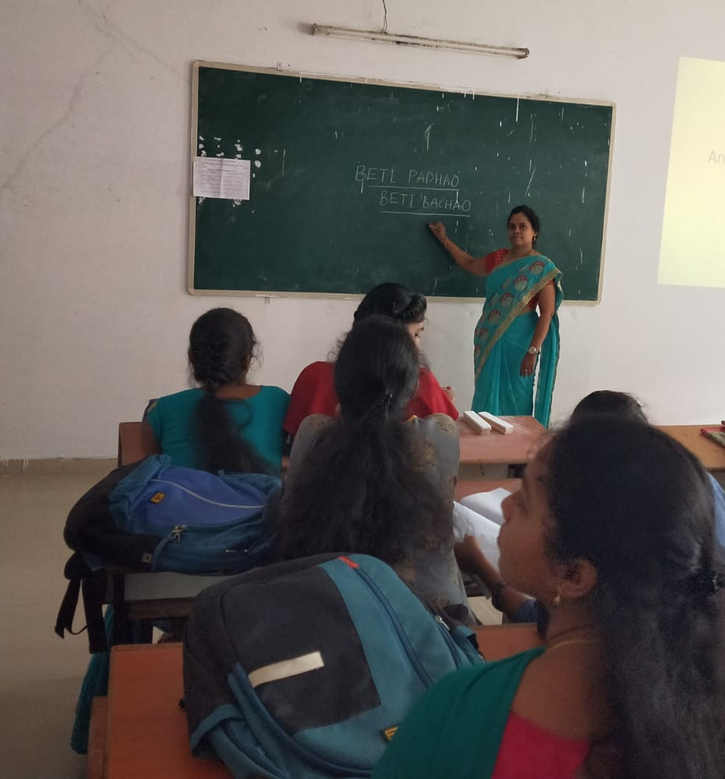

**The importance of allowing girl child to live and study was emphasized by Smt.J.Sandhya**

Women Empowerment -Extension activities

**Type of Activity** : Extension

**Title of Event**: **Challenges faced by women in 21st century by Smt.T.Anusha**

**Date**: 9.3.2021

**Name of organizing Departments**: Women Empowerment Cell & Women Protection Cell

**Names of coordinators**: Dr. C. Padmavati, Smt P. Rajitha, Ms K. Himabindu, T. Anusha

**Name & Designation of Resource persons**: Co-ordinator, co-cordinators and member.

**Number of Participants**: 53 students

**Activity details**:

The committee initiated to organize a program to create awareness regarding gender sensitization with volunteers of the committee.

The students were asked to highlight the Challenges faced by women in 21st century.

A few of the issues were highlighted regarding Girl child like

* Infanticide is the killing of the child within a year of birth. This is mainly because the female baby is not given the respect due to her.
* Child marriage is performed as they believe that a daughter is a burden to the family. So they try to relieve that burden by marrying her at an early age.
* Women’s health is of paramount importance. However it is something which is being given the least importance. Only a healthy person can perform the routine duties and ensure that the family remains too remains nutritionally complete.
* Girl education is something which cannot be neglected as there is always a family who is dependent upon the girl. Only a educated mother can ensure scientific diet to a family in ensuring the nutritional requirements to be fulfilled.
* Gender issues are common phenomena seen even in educated families.
* Beti Bachao is a slogan mainly to ensure that the female fetus and the children are able to survive due to creation of awareness among the parents.
* Problems of females at work place were debated and discussed. This is something which females have to be careful about.
* Signatures were collected from visitors.

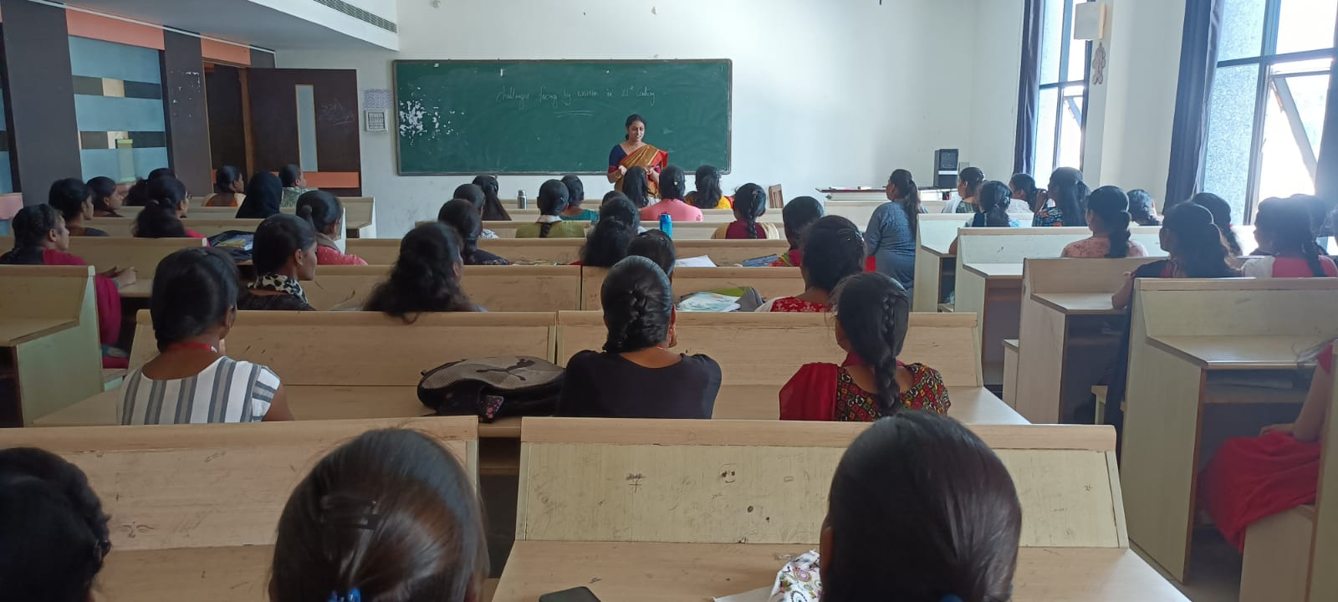

Challenges faced by women in 21st century by Smt.T.Anusha

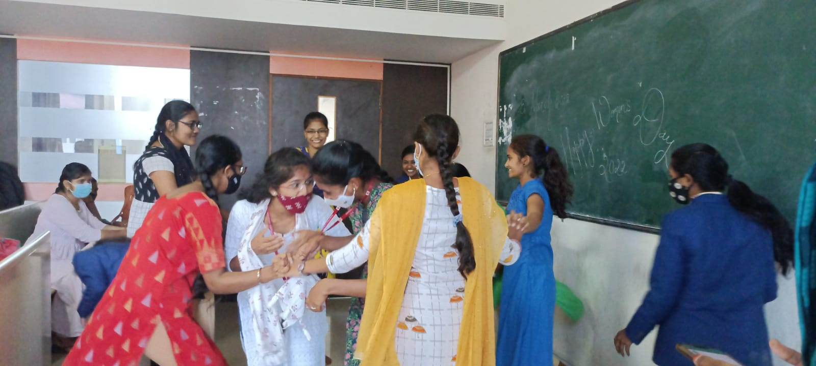

**Outcomes/Benefits:**

* The students came together in a platform exhibiting cooperation among themselves.
* They were able to understand the intricacies of the different problems.
* They opened up to express their viewpoints and high light various problems.
* Students played a skit to highlight the issues of women harassment.
* The skit played an important role in ensuring that the students understand the various problems.

**Gender Sensitization:**

It is extremely important to ensure that students develop a feeling of Equality. It is extremely important to understand self worth to gain confidence. This becomes the prime source to create awareness among the girl students regarding the problems they can face in and around them.To encourage thinking ability and creativity among them. Dr. C. Padmavati enlightening the students about Gender sensitization.

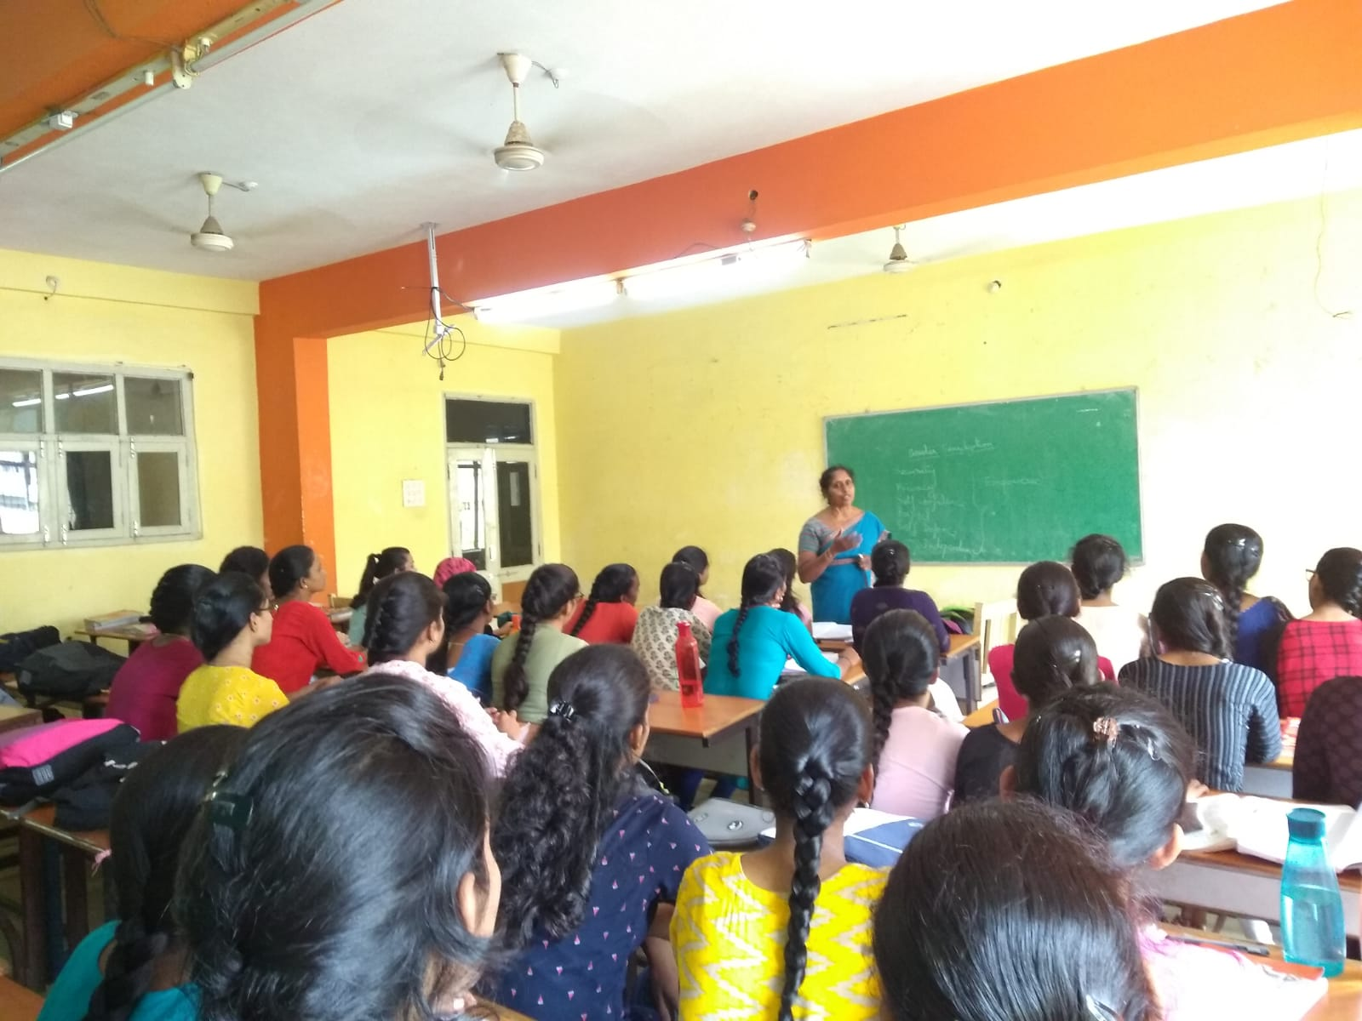

Dr. C. Padmavati On Gender sensitization.